[Name of Customer Agency]

TARGET STATE CONCEPT OF OPERATIONS

  - [Program Name]

Version 1.0

[Day, Month, Year]

  - Document History

Release No. | Date | Author | Revision Description
1.0 |  |  | Initial Draft Version

I have carefully assessed the Target State Concept of Operations for the <<INSERT NAME OF PROGRAM>>. This document has been completed in accordance with the requirements of the Office of Shared Solutions and Performance Improvement (OSSPI) Guidance.

MANAGEMENT CERTIFICATION - Please check the appropriate statement.

______ The document is accepted.

______ The document is accepted pending the changes noted.

______ The document is not accepted.

We fully accept the content within this project artifact and associated tasks.

_______________________________ _____________________
<<Insert Name>> <<Insert Date>>
<<Insert Title>>

_______________________________ _____________________
<<Insert Name>> <<Insert Date>>
<<Insert Title>>

Contents
Contents 4
1. Overview 5
2. Solution Concept of Operations 5
2.1. Proposed Solution Summary 5
2.1. Major Processes and Functions 5
2.2. Users and Other Stakeholders 5
2.3. Policies, Assumptions, and Constraints 5
2.4. Operational and Support Environment 5
2.4.1. Operational Concept 6
2.4.1.1. Infrastructure as a Service 6
2.4.1.2. Platform as a Service 7
2.4.1.3. Software as a Service 8
2.4.1.4. Business Services 8
3. Sample Operational Scenarios 9

Overview
<< Describe the purpose and objectives of the Concept of Operations. The Concept of Operations (CONOPS) document depicts the overall solution and provides a mechanism to describe expectations of the acquired service. The CONOPS describes the service and communicates the high-level characteristics and structures of the acquired solution to stakeholders. It is primarily a non-technical document presented from the viewpoints of various stakeholders (classes of users). The CONOPS is developed for numerous reasons:

• Gain stakeholder agreement on how the organization would operate with the new solution/service and ideal responsibilities between the organization and the providers
• Define the high-level solution concept
• Define the environment in which the solution will operate
• Derive high-level requirements

This document should be reviewed and approved by the Executive Sponsor, Business Owners, Program Manager, and Functional Lead.>>

Solution Concept of Operations

Proposed Solution Summary
<< Describe the operational concept from a high-level, integrated perspective and how the new solution will support the organization’s mission and strategic goals. The description is not a design, but a high-level, conceptual, operational description of the proposed solution. The use of graphics is encouraged for the as-is and to-be environments>>

Major Processes and Functions
<< Describe each major process and function that will be performed as part of the integrated solution. Include the process name, a high-level description of the process, and the business value of the process or function. Include high level process maps depicting the process or function >>

Users and Other Stakeholders
<< Identify and describe the user classes and stakeholders who will interact with the new solution or capability. Provide an explanation of how the user classes will interact with the new solution >>

Policies, Assumptions, and Constraints
<< Identify and describe the operational and support boundaries for the new solution>>

Operational and Support Environment
<<Based on the organization’s understanding of mission support operations, users, policies, assumptions, constraints, as-is environments, and business needs, describe the proposed target state for the service, and how it would operate in an organizational setting and provider environment.>>

Operational Concept
<<Describe the major interactive participants, players, systems, and interrelationships including the capabilities the organization is looking to retain and integrate and the capabilities the organization is looking to obtain or automate via a provider. The target state should explicitly describe the service(s) the organization is looking to acquire from a provider: Infrastructure as a Service (IaaS), Platform as a Service (PaaS), Software as a Service (SaaS), or Business Services and describe the service types: Technology, Workforce, and Advisory. Use the illustration below for reference.
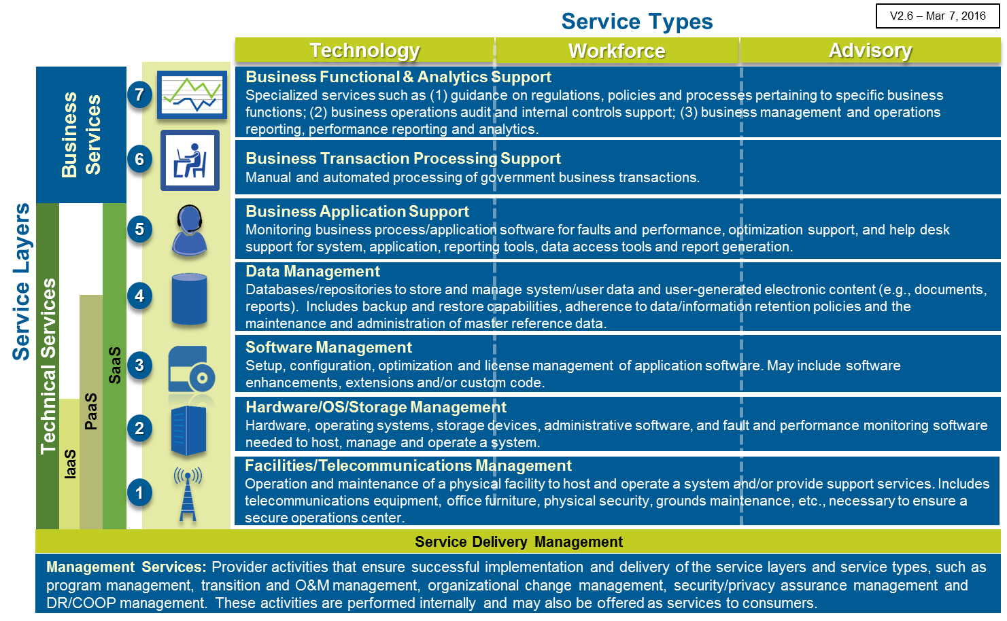

The following are the definitions of the service types:
- Technology: Facilities, physical assets, equipment, software and/or data needed to deliver the service
- Workforce: Human resources needed to plan, implement, operate, maintain and/or deliver the service
- Advisory: Human resources available to advise, guide, consult, audit and/or perform IV&V on the delivery of the service>>

Infrastructure as a Service
<< Describe the target state concept of operations for Infrastructure as a Service (IaaS), if the organization is looking to acquire this service. IaaS provides consumers the use of processing, storage, networks and other fundamental computing resources where the consumer is able to deploy and operate their own software, which can include operating systems and applications. The consumer does not manage or control the underlying infrastructure, but has control over guest operating systems, storage, and deployed applications; and possibly limited control of select virtual networking components. (At no point is the consumer given control over the physical WAN or LAN resources (e.g. routers, switches, firewalls, etc.)

Address whether the organization will use the following Service Types:
- Technology
- Workforce
- Advisory

Indicate the following for IaaS
- What capabilities the organization is looking to obtain from a provider versus retain
- A picture of the as-is systems environment and a notional picture of the target state systems environment including associated processes
- Must have business requirements for the service including availability, reliability, and maintainability requirements
- Conditions in which the service will be employed
- Description of the operating environment in which the service will be deployed
- Interoperability requirements
- How the solution will be supported in operations
- Potential operational, organizational, and user impacts of the new service and associated solution>>

Platform as a Service
<<Describe the target state concept of operations for Platform as a Service (PaaS), if the organization is looking to acquire this service. PaaS provides consumers with IaaS plus the ability to develop in and deploy onto the provider’s infrastructure acquired applications or applications created using programming languages, libraries, services and tools supported by the provider. The consumer does not manage or control the underlying infrastructure, but has control over the deployed applications and possibly configuration settings for the application-hosting environment

Address whether the organization will use the following Service Types:
- Technology
- Workforce
- Advisory

Indicate the following for PaaS
- What capabilities the organization is looking to obtain from a provider versus retain
- A picture of the as-is systems environment and a notional picture of the target state systems environment including associated processes
- Must have business requirements for the service including availability, reliability, and maintainability requirements
- Conditions in which the service will be employed
- Description of the operating environment in which the service will be deployed
- Interoperability requirements
- How the solution will be supported in operations
- Potential operational, organizational, and user impacts of the new service and associated solution>>

Software as a Service
<<Describe the target state concept of operations for the Software as a Service (SaaS), if the organization is looking to acquire this service. SaaS provides consumers with PaaS plus use of the provider’s applications running on the provider’s infrastructure (network, servers, operating systems, storage). The consumer does not manage or control the infrastructure or application capabilities, with the possible exception of limited user-specific application configuration settings

Address whether the organization will use the following Service Types:
- Technology
- Workforce
- Advisory

Indicate the following for SaaS
- What capabilities the organization is looking to obtain from a provider versus retain
- A picture of the as-is systems environment and a notional picture of the target state systems environment including associated processes
- Must have business requirements for the service including availability, reliability, and maintainability requirements
- Conditions in which the service will be employed
- Description of the operating environment in which the service will be deployed
- Interoperability requirements
- How the solution will be supported in operations
- Potential operational, organizational, and user impacts of the new service and associated solution>>

Business Services
<<Describe the target state concept of operations for Business Services including Business Transaction Processing Support and Business Functional & Analytics Support if the organization is seeking to acquire these services from a provider. Business Transaction Processing Support includes manual and automated processing of government business transactions and Business Functional & Analytics Support includes specialized services such as (1) guidance on regulations, policies and processes pertaining to specific business functions; (2) business operations audit and internal controls support; (3) business management and operations reporting, performance reporting and analytics.

Address whether the organization will use the following Service Types:
- Technology
- Workforce
- Advisory

Indicate the following for Business Services support:
- What capabilities the organization is looking to obtain from a provider versus retain
- A picture of the as-is systems and operating environment and a notional picture of the target state systems and operating environment including associated processes
- Must have business requirements for the service including availability, reliability, and maintainability requirements
- Conditions in which the service will be employed
- Description of the operating environment in which the service will be deployed
- Interoperability requirements
- How the solution will be supported in operations
- Potential operational, organizational, and user impacts of the new service and associated solution>>

Sample Operational Scenarios
<< Provide scenarios that show how the service will perform the objectives and meet the users’ requirements. A scenario describes a sequence of events, activities carried out by the user and the solution. Develop sample usage scenarios (as realistic as possible) for each major user class how the user will interact with the solution and what outputs are expected to be generated by the solution.>>

